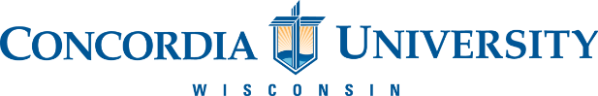

**Summer Global Engagement Institute**

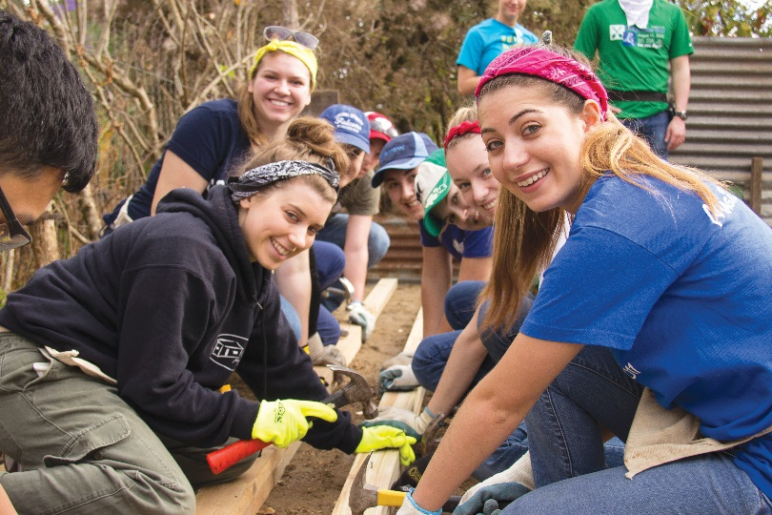July 6 – July 19

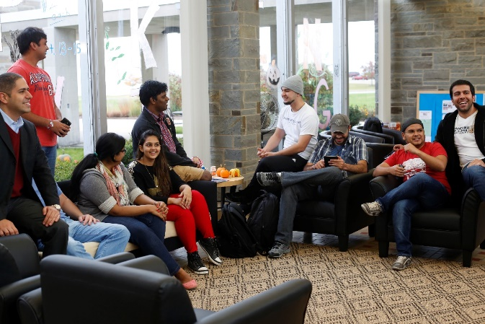

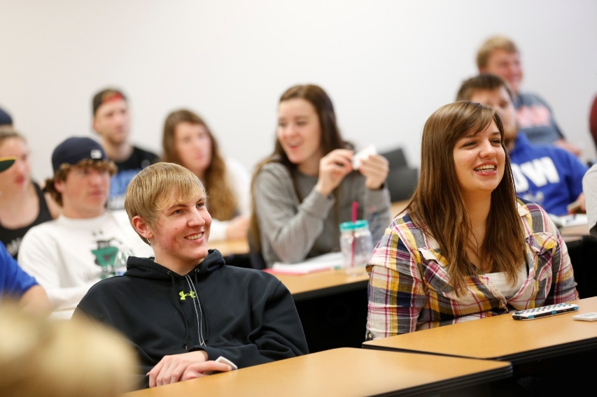

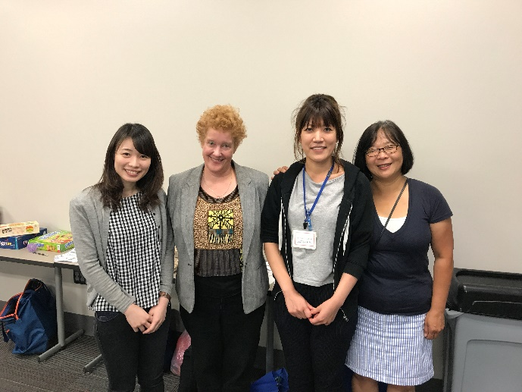

## Mission Statement of Concordia University:

Concordia University Wisconsin is a Lutheran higher education community committed to helping students develop in mind, body, and spirit for service to Christ in the Church and the World.

## Vision Statement of Concordia University:

Our vision is to be well known nationally and internationally as a premier Lutheran Christian university, widely recognized for meaningful integration of faith and learning. Our alumni will assume significant servant leadership responsibilities in the Church and communities across the nation and around the world.

## Mission Statement of the Summer Global Engagement Institute:

SGEI’s mission is to develop relationships with international institutions and students by providing opportunities to learn through cultural immersion and specialized academic programs. The program will promote Concordia’s name on an international level as a premier university and encourage international students to attend Concordia post-graduation.

## Program Overview and Student Learning Objectives

The purpose of the SGEI program is to instruct a group of international students about the culture and customs in the United States and introduce them to life in a U.S. Christian University. Throughout the program they will learn about the unique history of Concordia University and the surrounding Great Lakes area. They will take academic courses in Concordia that will inform students and promote the University’s academic programs. Additionally, students will be encouraged to develop relationships with Concordia’s instructors and students and integrate into their new environment. This program will also develop the students’ abilities to use English to communicate.

### Concordia University’s Academic Objectives:

By the end of the week long session, students will

* Know about Concordia’s unique history and educational environment
* Understand Concordia’s mission as a Lutheran University
* Know about Concordia’s programs for continuing education
* Have met with a variety of faculty and students that promote Concordia as an academic institution.
* Have developed their leadership abilities
* Have developed their abilities with intercultural communication.
* Know about the differences in education between their country and the United States.
* Have developed their abilities to communicate in English.

### Concordia University Community Objectives:

By the end of the week long session, students will

* Developed lasting relationships with faculty and students in Concordia University
* Understand cultural differences and similarities and can discuss them within a comfortable setting.
* Recognize Concordia University as a welcoming community that encourages language development and advanced learning.

### U.S. Culture and Customs Objectives

By the end of the week long session, students will

* Understand the culture in the United States and how it translates into a global setting
* Have learned about the history of the United States especially within the Great Lakes area.
* Have been introduced to Concordia’s association with the Lutheran Church and the beliefs that stem from this association.

## SGEI (2018)

This year, 15 to 20 students from Tianhua will be attending the camp from July 17th, 2018 to July 24th, 2018. Students will all come from the same university and will have a variety of majors. Tianhua University expects that students will improve their English abilities and learn about U.S. Culture and Customs. The courses will also cover materials in the students’ BSRS majors. The students are all college-level, and their ages range from 18 to 22. Their English levels range beginner-intermediate to advanced-intermediate.

**Cost**

The cost of this program is **$1900**, which includes housing, courses, admission into activities and food for the duration of the camp. It does not include cost of airplane tickets or personal spending money

## Global Leaders

Global Leaders are Concordia students who are interested in learning about new cultures and helping you practice English. Global Leaders come from a variety of majors on campus and are happy to answer any questions you have about life in the United States or at Concordia University.

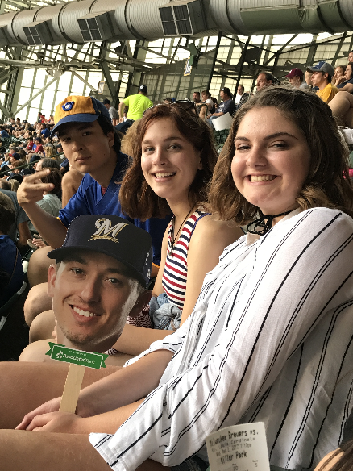 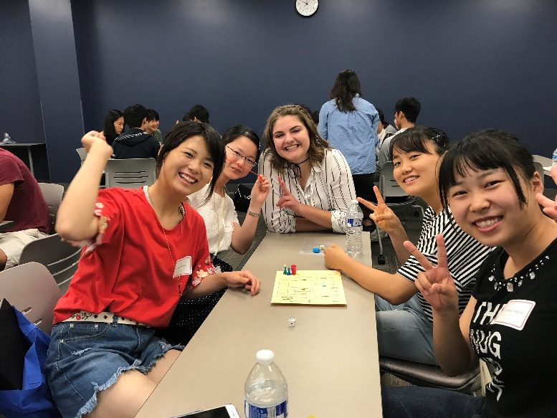

Summer schedule for SGEI

|  |  |  |  |  |  |  |  |  |
| --- | --- | --- | --- | --- | --- | --- | --- | --- |
| Day | Date | 7-8 | 8-12 | 12-1 | 1-4 | 4-6 | 6-7 | 7-9 |
| 1 | Friday  July 6th, 2018 | breakfast |  |  | Students arrive on campus and check-in to their dorms | | | |
| 2 | Saturday  July 7th, 2018 | breakfast | Ice Breaker Activities  ESL Class | Lunch |  |  | Dinner | GL Activities |
| 3 | Sunday  July 8th, 2018 | breakfast | Church Visit | Lunch | Trip to Holy Hill National Park | Walmart Shopping Trip | Dinner | Youth Group |
| 4 | Monday  July 9th, 2018 | breakfast | ESL | Lunch | Anatomy and Physiology with Dr. King | Free time | Dinner | Bonfire on the Beach |
| 5 | Tuesday  July 10th, 2018 | breakfast | ESL | Lunch | Nursing Lab | Free time | Dinner | Bowling in Cedarburg |
| 6 | Wednesday  July 11th, 2018 | breakfast | BBQ and Games at Lion’s Den Beach   * Nature Hike - Biodiversity Seminar | | | | Dinner | GL activities |
| 7 | Thursday  July 12th, 2018 | breakfast | ESL | Lunch | Healthy Lifestyles  Nutrition | Free time | Dinner | Go Karting/ Laser Tag |
| 8 | Friday  July 13th, 2018 | breakfast | ESL | Lunch | -Feed America Volunteering | Free time | Dinner | Volleyball/ Kickball Tournament |
| 9 | Saturday  July 14th, 2018 | breakfast | Down Town Milwaukee | Lunch | Trip to Pleasant Prairie Shopping Center | Dinner  King and I  Thai Food | Bastille Days  Outdoor event | |
| 10 | Sunday  July 15th, 2018 | breakfast | Trip to Devil’s Lake National park   * Day hike -Boat Rental - Wilderness Education | | | | Dinner | Night Hike/ Bonfire |
| 11 | Monday  July 16th, 2018 | breakfast | ESL | Lunch | Psychology with Dr. Samuel | CN prep | Dinner | GL Activities  Culture night prep |
| 12 | Tuesday  July 17th, 2018 | breakfast | ESL | Lunch | Physical Therapy Course | CN prep | Culture Night Dinner | |
| 13 | Wednesday  July 18th, 2018 | breakfast | Trip to Chicago  -Shedd Aquarium -Architecture Boat tour -Millennium park | | | | Dinner at Giorgano’s Pizzeria | |
| 14 | Thursday  July 19th, 2018 | Breakfast w/ Concordia Staff | | Lunch | Final Exam (ESL, Healthcare) | Free time | Dinner | GL activiites |
| 15 | Friday  July 20th, 2018 | breakfast | Students depart for Airport | | | | | |
| 16 |  |  |  |  |  |  |  |  |

Description of Events

## Academic Courses

The Academic courses offered in the SGEI program include a variety of materials covered in the Health Science Department. The activities in these courses are hands-on, and you will interact in simulations and labs that engage you on multiple levels. Additionally, you will be taking the course with

## English as a Second language Courses

During your time during the institute, you will practice English by engaging in different courses. This includes

* + Speaking and Listening
  + Reading and Writing
  + TOEFL and IELTS preparation
  + Cultural instruction
  + Opportunities to practice speaking with our dedicated Global Leaders

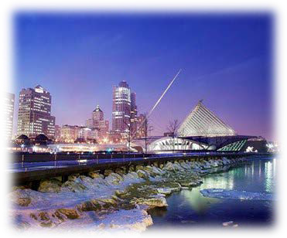

**Milwaukee City**

The city of Milwaukee is home to diverse

traditions, heritages and cultures that have helped our city to grow and prosper. With attractions such as the Milwaukee Art Museum, Discovery World and the Harley-Davison Museum to go along with

our many ethnic festivals, sporting events, concerts, restaurants and beautiful scenery, Milwaukee is the perfect destination for all.

威斯康星州最大的城市密尔沃基，坐落于美丽的密歇根湖畔。啤酒的故乡密尔沃基拥有机械制造等众多工业部门和游览胜地。是您旅游参访的首选。



**Milwaukee Art Museum**

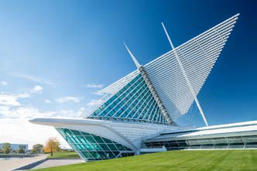



The Milwaukee Art Museum collects and preserves art, presenting it to the community as a vital source of inspiration and education. 30,000 works of art. 400,000+ visitors a year. 125

years of collecting art. The 341,000-square-foot Museum includes the War Memorial Center (1957) designed by Finnish-American architect Eero Saarinen, the Kahler Building (1975) by David Kahler, and the Quadracci Pavilion (2001) created by Spanish architect Santiago Calatrava.

密尔沃基美术馆成立自 1888 年，125 年来收集并拥有 30,000 件艺

术作品，每年超过 40,000 参观人次。密尔沃基美术馆现已成为密尔沃基市著名地标和全威州重要的资源之一。其著名的拱型建筑Quadracci Pavilion 是由西班牙建筑师 Santiago Calatrava 所设计。

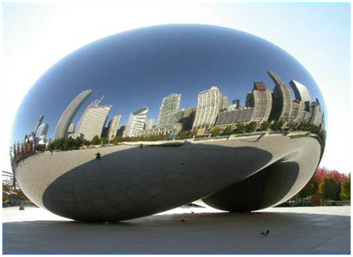

**Millennium Park**

Millennium Park, a large park in Chicago,

Illinois, USA. The park is an important cultural and entertainment center of the shores of Lake Michigan, and covers the entire north-west side of Grant Park 24.5

acres (99,000 square meters) of land. As of 2009, the Millennium Park, is a full-Chicago, the second most popular tourist attractions, second only to the Navy Pier (Navy's Pier).

芝加哥千禧公园建成于 2004 年 7 月，由著名建筑设计师弗兰克盖

里设计完成，面积为 24 英亩，共耗资 5 亿美元，是“后现代建筑风格”的集中地。露天音乐厅、云门和皇冠是千禧公园中最具代表的三大后现代建筑。公园中间由英国人阿尼什•卡普尔艺术设计的云之门，人称「银色豆子」，是用不锈钢制成的超大型光面金属球，在映照出芝市摩天大楼倒影的同时，也如一个巨大哈哈镜，可以让游

人置身于其中。

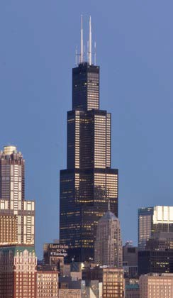

**Willis Tower**

Willis Tower (formerly named and still commonly

referred to as Sears Tower) is a 108-story, 1,451- foot (442 m) skyscraper in Chicago, Illinois, United States. At the time of its completion in 1973, it was the tallest building in the world, surpassing the World Trade Center towers in New York, and it held this rank for nearly 25 years. Willis Tower is the second-tallest building in the United States and the eighth-tallest freestanding structure in the world.

威利斯大厦，是位于美国伊利诺州芝加哥的一幢摩天大楼，楼高

442.3 米，共地上 108 层，地下 3 层。大厦在 1974 年落成，超越纽约的世界贸易中心，成为当时世界上最高的大楼。落成时名为西尔斯大楼，2009 年 7 月 16 日改为现名，但原名较常被公众使用。

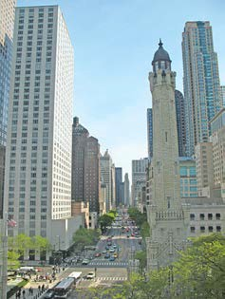

**Michigan Avenue**

As the home of the Chicago Water Tower, the Art

Institute of Chicago, Millennium Park, and the high-end shopping on the Magnificent Mile, it is a street well known to Chicago natives as well as tourists to the city. Michigan Avenue also is the main commercial street of Streeterville.

密歇根大道是世界上最著名的商业街之一，有包括从众多的奢侈品商店，大型的百货公司到特色小店。它因密歇根湖而得名。起初密歇根大道基本上是住宅区。在 1860 年代，昂贵的大住宅主宰着密歇根大道。1871 年芝加哥大火以后，密歇根大道上从议会街到芝加哥河的所有建筑全被烧毁。大火之后密歇根大街立即得到重建，仍然保持了住宅区的特色，但是已经不再直接濒

临密歇根湖。